Pan Ohio Hope Ride
Merchandise Order Form
July 24-27, 2014
Cleveland, Columbus, Cincinnati
www.panohiohoperide.org

Name and Address: ________________________________________________**Merchandise will be shipped out to the address you provide**
________________________________________________
________________________________________________
Phone __________________ Email _____________________________________________________

Socks $10
S/M _____ Quantity L/XL _______ Quantity
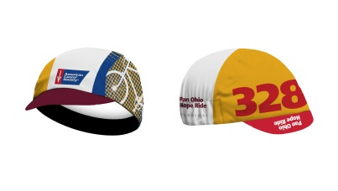
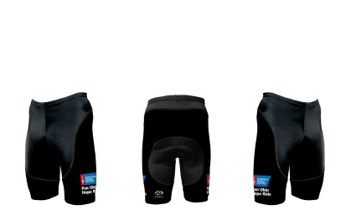
Cap $15
One Size _____ Quantity
Shorts (Black Design) $60
Men’s S _____ M _____ L _____ XL ____ XXL ____
Women’s XS _____ S _____ M _____ L ____ XL ____

Poster $25
____ Quantity

Total ______________________
**All merchandise is considered as a sale including Sales Tax built in and is not tax-deductible.
Please send check made payable to American Cancer Society or credit card form to:
American Cancer Society Credit Card Orders can be faxed to:
Pan Ohio Hope Ride Merchandise 877.227.2838 attn: Paul Purdy
10501 Euclid Ave.
Cleveland, OH 44106
Total Amount ___________________________
Circle: VISA MC AMEX DISC Name on Card _____________________________________
CC#: _________________________________________ EXP Date: ___________________
Signature________________________________________________________________________

