

*Celebrate the arrival of spring with the delivery of beautiful daffodils and tulips*

***2019 Flower Options***

* *Bunch of Daffodils: $10*
* *New! Bunch of Tulips: $10*
* *Mini-Potted Daffodils: $15*
* *Gift of Hope: $25*

*(flowers will be sent to a local hospital)*



*“Through the daffodil, the first flower of spring, this campaign brings a symbol of hope to cancer patients and those affected by the disease.”*  
Give Daffodils. Give Hope.

*For more information and/or to order contact:*[*maryann.kennedy@cancer.org*](mailto:maryann.kennedy@cancer.org) *OR 717.534-1487  
See back for more details*

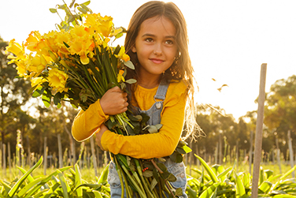



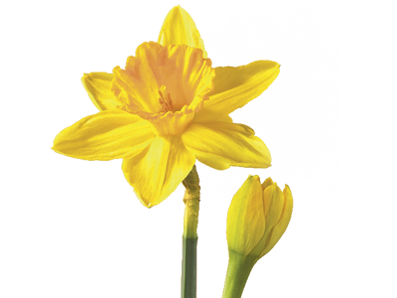**

***Daffodil Details!****Use provided forms to take orders for daffodils and tulips.*   
 **Forms:**

* **Daffodil Days Flyer** – The front of this sheet is a flyer for you to hang up and spread the word about Daffodil Days!
* **Order Tracking Sheet** – This is the form that you should keep for yourself so that you know how to distribute your daffodils. *(Encourage your friends and family to take a sheet and take orders too!)*
* **Coordinator Order Form** – This is the form that should be returned to the American Cancer Society with your TOTAL order on it.

***\*Money is due with orders by February 15th 2019***

*When you participate in Daffodil Days, you not only provide hope and cheer to the recipients of the flowers but will also be a continuation of support for American Cancer Society’s efforts to finish the fight against cancer by funding lifesaving research and life-changing programs for patients and their families.****This year we are partnering with Royer’s Flowers & Gifts to make the experience seamless and easy for you!****\*All orders should be placed through the American Cancer Society and not through Royer’s\**

**\**

**Daffodil Days Info Sheet**Give Daffodils. Give Hope.

**Royer’s Pick-up Options:**

*(Please indicate your preferred pick-up location on your order form)*

***Flower pick-up day is Wednesday, March 20th, 2019***

* Camp Hill, 3015 Gettysburg Road, Camp Hill, PA 17011
* Harrisburg, 907 Orchard Street, Harrisburg, PA 17109
* Harrisburg, 4621 Jonestown Road, Harrisburg, PA 17109
* Hershey, 304 W. Chocolate Avenue, Hershey, PA 17033

***\*Orders over $500 (Excluding Gifts of Hope) will be delivered!***

**

Thank you for your support!

***Important Dates: Orders Due: February 15th 2019 Flower Pick-Up: March 20th 2019***

*Contact MaryAnn at* [*maryann.kennedy@cancer.org*](mailto:maryann.kennedy@cancer.org) *OR 717.534-1487with questions and/or to place your order!*